**Tiket 571**

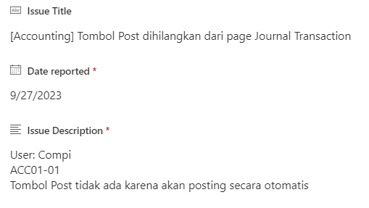

**TIKET 573**

**TIKET 575**

**TIKET 257**



